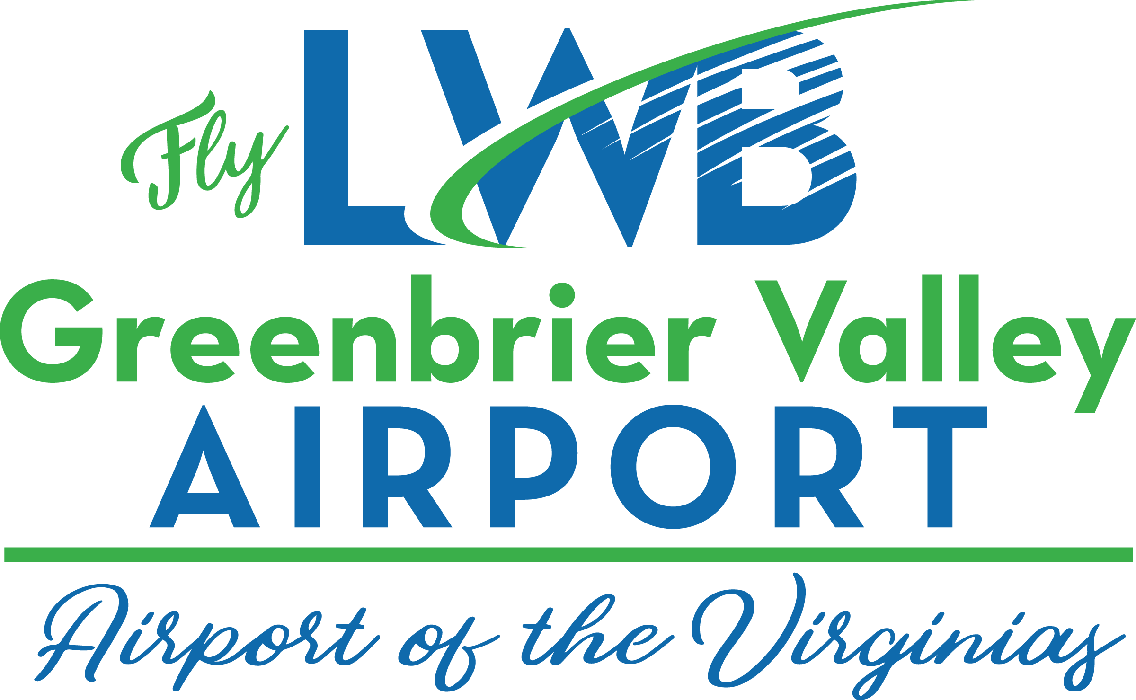
Press Release

Passenger & Private Aviation Traffic Come Roaring Back at LWB in May

Passenger Counts Jump To Near Pre-COVID Numbers

June 11, 2021 Lewisburg, WV: The Greenbrier Valley Airport today released passenger enplanement numbers for May 2021, as reported by Skywest Airlines, operating for United Airlines at LWB. A total of 1,092 passengers boarded commercial aircraft at Greenbrier Valley Airport in May, compared to 54 in May 2020 during the height of the COVID-19 pandemic.
“We are so happy to see passenger traffic rebounding at this pace. We know there is a strong market in this region, and a strong market of travelers coming to visit area resorts, stated Brian Belcher, Airport Director. Belcher added, we continue to see a strong leisure market and now we see the business traveler returning to the sky.”
Greenbrier Valley Airport continues to see heavy private aviation flights flying to and from the airport. This attributed to strong fuel sales for the airport during May. Fuel sales were the best since 2005 and were 161.3% higher than May of 2020, and were 16% higher than 2019 fuel sales volume, the year before the pandemic.
“We continue to see impressive private aviation traffic at LWB”, said Belcher, adding “for many years this airport has always been a leader in general aviation traffic flying into West Virginia. After being under pandemic guidelines for more than a year, people seem to want to travel and this region is the perfect place to get away for a vacation. This area has everything you want for outdoor vacations, from amazing golf courses, rivers, trails, world-class resorts and America’s Coolest Small Town, we have it all.”
“The two Virginias offer a unique vacation opportunties including multiple resorts, national parks and vistas. Extreme adventures and fresh mountain air are waiting for our visitors,” stated, Greenbrier County Airport Authority, Board Chair, Deborah Phillips.
LWB is served by United Airlines, flying to Chicago’s O’Hare Airport and Washington’s Dulles Airport, allowing you to connect to almost anywhere in the world.
- 30 –
For more information:
Please contact Brian Belcher, Airport Director at 304 645-3961 (Office) or 304 992-4204 (Cell) or email brianb@gvairport.com ; or check out our website: www.myLWB.com
Follow these social media accounts for news and updates about LWB : @flyLWBWV gvairportwvlwb on TicToc, and Greenbrier Valley Airport on Facebook.

