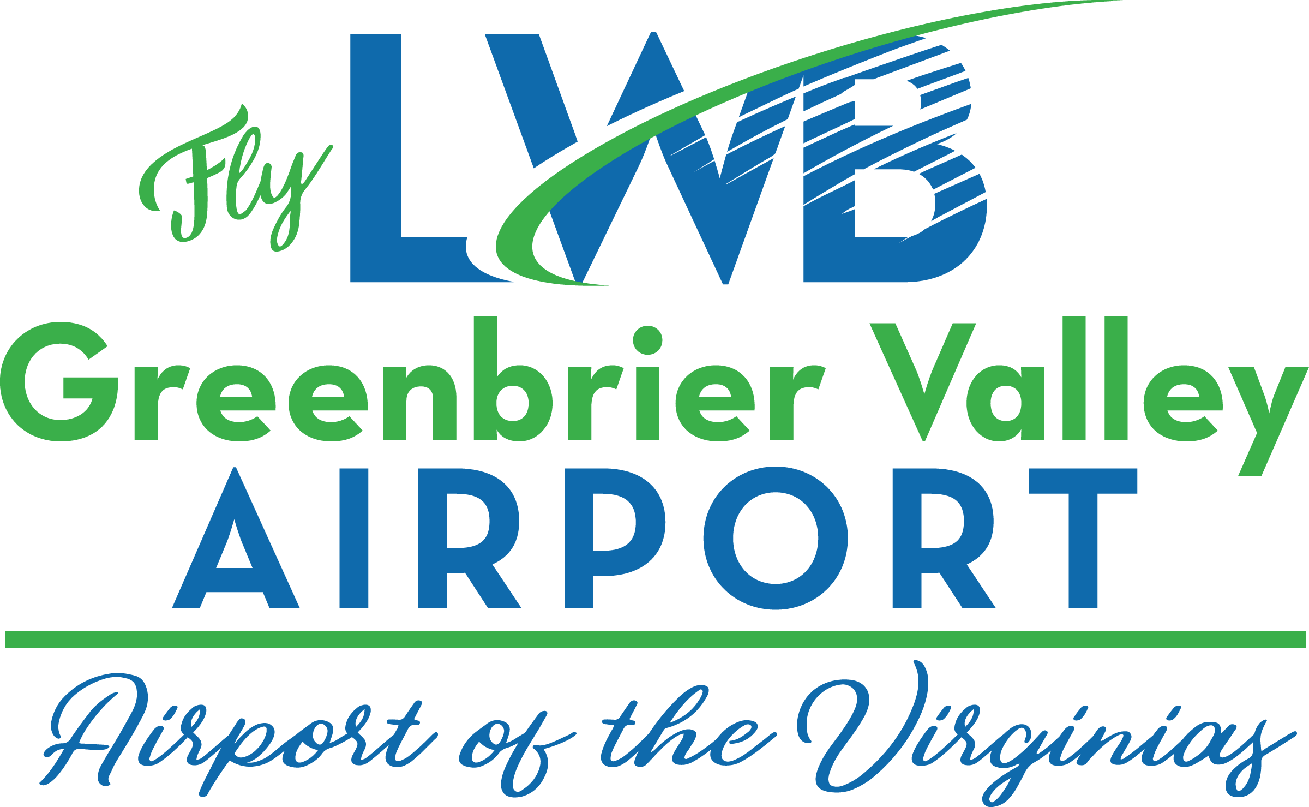
Press Release

Contour Airlines to Start Service at Greenbrier Valley Airport on November 1

Connecting This Region to the American Airlines Charlotte Hub

September 21, 2022, Lewisburg, WV: On Tuesday, August 30, 2022, The U.S. Department of Transportation awarded Contour Airlines based in Syrma, TN the Essential Air Service contract for Greenbrier Valley Airport (LWB) located in Lewisburg, WV
Contour Airlines flies the Embraer 135 and 145 regional jets configured with 30 seats per aircraft. Contour will serve Lewisburg from the American Airlines Charlotte hub. American offers nearly 6700 flights daily to 350 destinations worldwide. Contour has an agreement with American Airlines so connecting to American Airlines flights is easy. You can purchase tickets at https://www.contourairlines.com/ and if connecting to an American flight you can purchase your tickets at www.AA.com
“We’re excited to have Contour Airlines start service to/from the Greenbrier Valley Airport and the region,” stated Brian Belcher Airport Director. “Contour Airlines serving the Charlotte Hub opens up the Southern part of the United States to easily access all the WV tourism options that this region has to offer” added Belcher.

“Contour is excited to bring reliable jet service to the Greenbrier Valley. Travelers will appreciate our low fares and worldwide connectivity through our relationship with American Airlines,” said Matt Chaifetz, CEO of Contour Airlines. “We thank the community and the U.S. Department of Transportation for their support and selection of Contour and look forward to serving this market for many years to come."
***30 ***
For more information:
Please contact Brian Belcher, Airport Director at 304 645-3961 (ext. 223) (Office) or 304 992-4204 (Cell) or email brianb@gvairport.com; or check out our website: www.myLWB.com

Follow these social media accounts for news and updates about LWB: @flyLWBWV on Twitter, gvairportwvlwb on TikTok, and Greenbrier Valley Airport on Facebook.

